DOKUZ EYLUL UNIVERSITY
ENGINEERING FACULTY
DEPARTMENT OF COMPUTER ENGINEERING

CME1251 PROJECT BASED LEARNING – I
FINAL REPORT
PROJECT – I

ADVENTUROUS FROG

by
Batuhan METİN
Kerem KIRGÖZ
Sadullah CİHAN

Lecturers
Assoc. Prof. Dr. Mehmet Hilal ÖZCANHAN
Res. Asst. Elife ÖZTÜRK

22.11.2019

CHAPTER ONE
PROGRESS DESCRIPTION
To get to the bottom of the project and understand what kind of path we took during our correlation in terms of team management and create an efficient and maintainable product. We should look at what we have learned to have the ability to develop such a product. We start with learning the assets we would need through the way.

First week:
We managed to we create our communication network with trello and start to learn the details we need to use to create a neat project. We asked a lot of questions to each other and give notification through the all way of building the mainframes and structure of our work. We increase our knowledge about the details and important parts gradually. For instance, using ‘Arrays’. However, like any other projects we encountered inevitable problems while we were building our algorithm. Even though, it was a hard and slow process. We proceed through our schedule. It was critically important to communicate and build an understandable and readable solution strategy to make our job easy for the coming steps of developing. Especially while writing our code.

Second week:
We start to determining the variables we need to use to make everything readable and clean, we pay attention to naming process because to be not confused we know the fact that we need to use variables in a good coding style. We added some crucial important part of our project to our flowchart like the rules we need to code and like the path we need to build our code on. We added moving frog on our code.

Third week:

We started to do some real coding and understand the fact flowcharts are crucially important for further steps in our way to make everything easier to understand.

We help each other so it was way easy to understand each others code. Each of us made the things that assign to us and completed. When we encountered a problem with our code we made research to overcome with it. So, with this was we learned lots of new stuff for c#. “Array” was one of the codes we learned in our classes and it was really useful for our work. Also, this week was too tough for all of us. Because we have a midterm week. Hence, we were forced. We practice it a lot and then finally added it to our project with after finding errors and editing.

Fourth week:
It was one of the most important parts of our project because it was time to organize everything and create a good appearance for our group. To do it, the work that we did last weeks was really helpful. After completing our codes finally, we were able to show what we have done for the last 4 weeks. To be able to do it we started doing our documentation first. It was a good idea to do it first because after that we were able to shape another part of our presentation around it. Everybody was able to handle their documentation part because everybody knew what they are doing and participate in every aspect of the project. Then, we managed to create an appealing poster which was reaching the criteria.

CHAPTER TWO
TASK SUMMARY

Completed Tasks
Sadullah Cihan :
Firstly we design our solution strategy. Then, we focused on our goal. We organized ‘trello’ for team communication. We have developed frog motion and cars motion. Also, we have designed 2 different speeds of cars which are assigned randomly. Besides, we solved our ‘Thread.Sleep()’ issue. Finally, we made a poster and this final report.

Kerem Kırgöz :
First of all, we discussed the project and designed a solution strategy. After that, we created some of the necessary variables and screens. Then, we made the frog motion. After that, we have created cars and made them move. When those parts were done, we designed the levels and scoring. While doing all of these, we have tested the game to make it work properly.

Batuhan Metin :
At first, we have learned ‘one-dimensional arrays’. Then we start the coding process. We produced cars randomly and integrated 6 different levels. We coded game over message and frog dies. I mean, if the frog stops on the road the car will crush the frog.

Incomplete Tasks: Reasons and Explanations
Sadullah Cihan: We have accomplished the project.
Kerem Kırgöz: There is no incomplete task.
Batuhan Metin: We did our best. Hence, we have completed the project.

Additional Improvements to the Project
Sadullah Cihan:
I wish we had had more time to focus on this project. Because weeks is too insufficient to develop a game like this. Also, colouring background is very well for a nice appearance. So that we have added ‘Console.ForegroundColor = ConsoleColor.Blue’ command to change the font.

Kerem Kırgöz:
We have used the "Console.ForegroundColor = ConsoleColor.Blue;" to make the game more attractive.

Batuhan Metin:
We change the font colour. This is so attractive for our team.

CHAPTER THREE
EXPLANATION of algorıthms

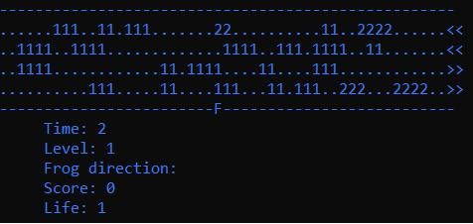
Screenshots

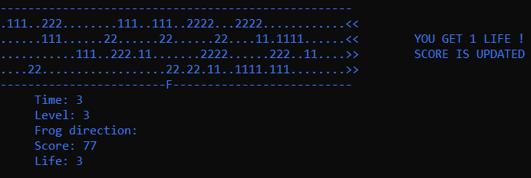
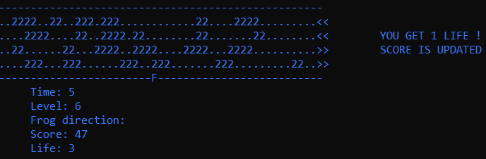
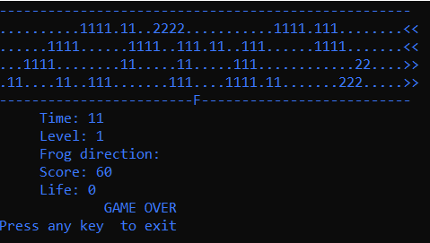

Functions

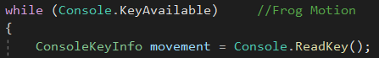

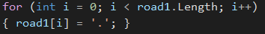

  - Algorithms and Solution Strategies

Sadullah Cihan: Firstly, we designed our solution strategy. After that, we start coding altogether. We had to notice that the project is tough. However, we have coded creating random cars. Also, we added 6 levels which are different from one another. From my point of view, this project is a great experience for all of us.

Kerem Kırgöz: We needed to write a game, which there is a frog who is trying to pass over the road. There are four roads, two borders, two car types and 24 cars in total. First and second roads are left direction, third and fourth roads are the right direction. At each direction, there are 12 cars. At the first level, 10 of those cars in one direction are type-1 which are slower and two of them are type-2 which are faster cars. At each level, the type-1 number goes down by 2 and type-2 number goes up by 2. There are 6 levels. The frog can be moved with direction keys. If frog get hit by a car, it loses a life.

Batuhan Metin: First of all, we have learned how to use efficiently ‘one- dimensional arrays’. Then we coded together. The thing is to create a well organized and readable code is to be strategic. The way to do is thinking before doing. So to overcome the problems we need to analyze the problem and rephrase it like the way we can understand it. We tested our code to solve all posible errors. Finally, we solved all the problems that we have encountered.

CHAPTER FOUR
PROBLEMS ENCOUNTERED
Sadullah Cihan:
Firstly, we did not know what to do in this project. Understanding the game was very tough. However, we discussed and created solution alternatives. The second problem is that we have a little bit of knowledge on how to code an array with C#. Hence, we were forced.
Next week, we clutched array subject. From my point of view, everything was too fast after that point. Because we had a midterm week. We had to study both midterms and this project.
The third week, The project development process was slow due to midterms. However, last week we accomplished most of the missions.

Kerem Kırgöz: The biggest problem we have encountered was that our Algorithms and Programming I lessons were going slower than our Project Based Learning I lessons. For that reason, we always had to learn the stuff we need to use in this project before we learn them at lessons. The second big problem we have encountered was, there was a big difficulty gap between the first and the second project. But also, project two was given at the same time as our visas.

Batuhan Metin: First, I faced problems with understanding the game. I could not figure out how I move the frog in all directions. Also, I don’t know the Console.KeyAvailable function and how can I use it perfectly. Another problem is that this project is too tough than the first project. Hence, we had to make research a lot. However, we accomplished our missions.

CHAPTER FIVE
conclusıon

In conclusion, we learn how to create a ‘one-dimensional array’ which let us help to move something algorithmically.
We also learned about the fundamentals of c# like it’s variables and importance of it. Social correlation of our group gave us a significant experience for next projects even for our lives. It let us create in-group communication skills and organization skills. Technically we have learned about the usage of arrays motion, how to create distinct new moving, how to use operators like a boolean flag.
REFERENCES
Herbert Schildt, C# 4.0: The Complete Reference, McGraw-Hill, 2010.
Paul Deitel, Harvey Deitel, C# 2010 for Programmers, Pearson Education, 2011.
https://www.kodevreni.com
https://www.tutorialspoint.com/csharp/csharp_arrays.htm
https://docs.microsoft.com/tr-tr/dotnet/csharp/programming-guide/arrays/single-dimensional-arrays
https://docs.microsoft.com/en-us/dotnet/csharp/programming-guide/
https://www.canva.com

AppendIx A
Poster of the Project

